NOTICE AND AGENDA OF A CALLED MEETING OF THE CITY COUNCIL OF THE CITY OF BARTLETT, TEXAS

Notice is hereby given that the City Council of the City of Bartlett, Texas will hold a

Special Called Meeting

5:30PM
Monday, November 20th, 2023 Bartlett City Hall
140 W Clark Street, Bartlett, TX 76511

For citizen comments, please contact Brenda Kelley, City Clerk at ( municipalcourt@bartlett-tx.us).

[ CALL TO ORDER, DECLARE A QUORUM, PLEDGE OF ALLEGIANCE, AND INVOCATION

I CITIZENS COMMUNICATION
(The City Council welcomes public comments on items not listed on the agenda. However, the Council cannot respond until the item is posted on a future meeting agenda. Public comments are limited to 3 minutes.)

I REGULAR AGENDA: REVIEW/DISCUSS AND CONSIDER ACTION

- Consideration and possible action to approve a Resolution canvassing the votes of the November 7, 2023 Election, declaring the results official.
- Consideration and possible action to enter into a legal professional services agreement with Eccles & McIntosh, PC.

I EXECUTIVE SESSION:

In accordance with Texas Government Code, Section 551.001, et seq., the City Council will recess into Executive Session (closed meeting) to discuss the following:

- §551.074 - Deliberate the appointment, employment, duties, and compensation of a public employee or officer regarding: (i)

Reconvene into Open Session:

a. Take action, if any, on matters discussed on Executive Session.

I FUTURE AGENDA ITEMS

I ADJOURN

All items listed on the agenda are eligible for discussion and/or action. The City Council reserves the right to retire into executive session at any time during the course of this meeting to deliberate any of the matters listed, as authorized by Texas Government 551.071 (Consultation with Attorney), 551.072 (Deliberations about Real Property), 551.073 (Deliberations about gifts and donations), 551.074 (Personnel Matters), 551.076 (Deliberations about Security Devices) and 551.086 (Economic Development). All final deliberations and actions of the governing body shall be held in an open meeting as required by Texas Government Code 551.102.

I certify this agenda was posted, pursuant to Texas Government Code 551.043, at least 72 hours prior to the commencement of the meeting in accordance with the Texas Open Meetings Act.

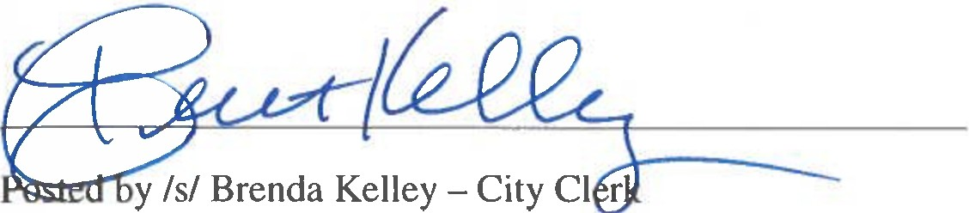
Posted Friday, November 17th, at or before 7:00 P.M.

